Trading in the MOMENT means trading an open 2hr candle. When 2hr chart is in trend with Daily then try to find entry off of Support/Resistance on 2hr or Daily charts or fine tune off 1hr. If 2hr is in consolidation with daily then trade off Support/Resistance on 2hr only. Always trade ROMAR trend in consolidation.
Create notes on your plan of entry as the market moves. Retraces are valuable as they will hit trend indicators for entry.
20 pips profit if already in trend.
40 pips profit if trend just starting.
The 2hr ROMAR is the true source for the trading TREND.
Daily ROMAR is key to direction turn. When EMA crosses look for turn.
When ROMAR is same on all charts we are in trend (trade with trend only). If they are not same then we are in consolidation and can trade both ways.
If PSAR is in Trend and market opens beyond PSAR and it does not flip then continue trend.
White crossing purple eliminates PSAR.
Psar will flip at EMA for Purple crossing.
Purple & White are for swing trend. They can hold market in trend or consolidation before direction change.
Smooth can hold market in swings. In consolidation look for which side of Purple Smooth is for trend...
----Above Purple trend is down----Below Purple trend is up.
EMA is secondary trend indicator. Purple crossing will determine swing trend. Red and Green arrows indicate market cross of EMA.
Four Horseman: Purple, White, Smooth and PSAR will deliver a visual for each swing. White & Smooth must cross Purple before taking a trade. EMA must
also cross Purple in consolidation ( slider ). If it doesn't then original trend will continue.
Fibo will flip with new high or new low. The contour lines show current range of market and are useful in spotting breakouts.
Bolinger Bands in consolidation if hit will retrace to EMA or opposite band in uptrend. If hit during downtrend then retrace may only be to Purple, White or
Smooth.
Swings are retraces in a trend. Usually back to Purple, White, Smooth or PSAR then continue trend.
DB and SAR are lines indicating swings. DB is long term and SAR is short term. SAR is for trading swings and for trend continuation.
DB will move from candle to candle in a trend.
Once SAR attaches with DB then DB is in control. SAR will stay with DB until a new high or low is determined.

Attached Image
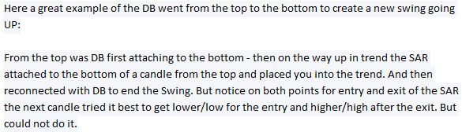

Attached Image
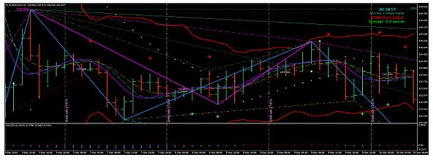
Attached Image
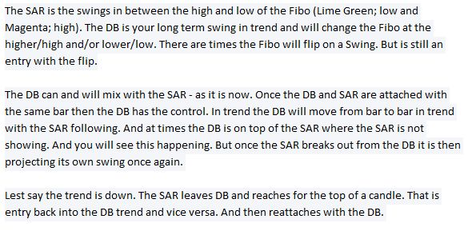

Attached Image
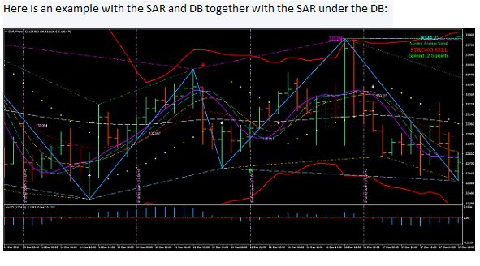
Attached Image
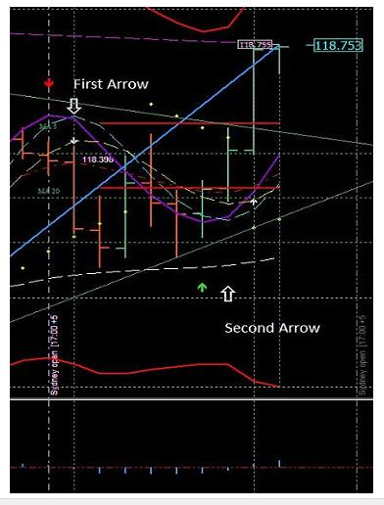
Attached Image
